AI ASSITED CODING

ASSIGNMENT 2.1

NAME:N.RUKMIKI

ROLL NO:2403A52404

BATCH:14

Task Description #1  
● Use Google Gemini in Colab to write a Python function that reads  
a list of numbers and calculates the mean, minimum, and  
maximum values

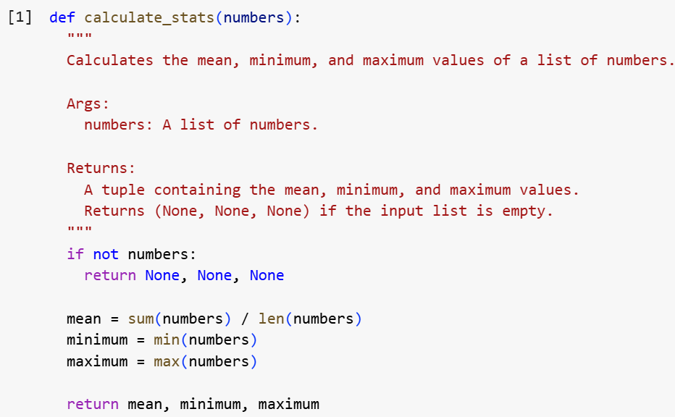

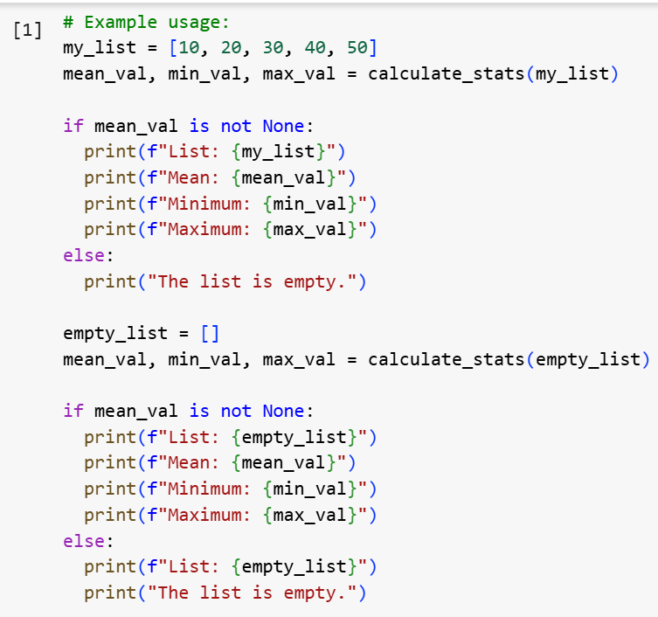

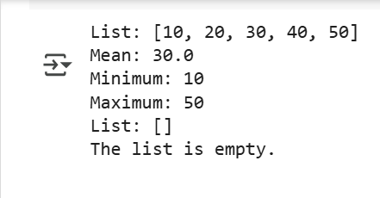

Task Description #2  
● Compare Gemini and Copilot outputs for a Python function that  
checks whether a number is an Armstrong number. Document the  
steps, prompts, and outputs.

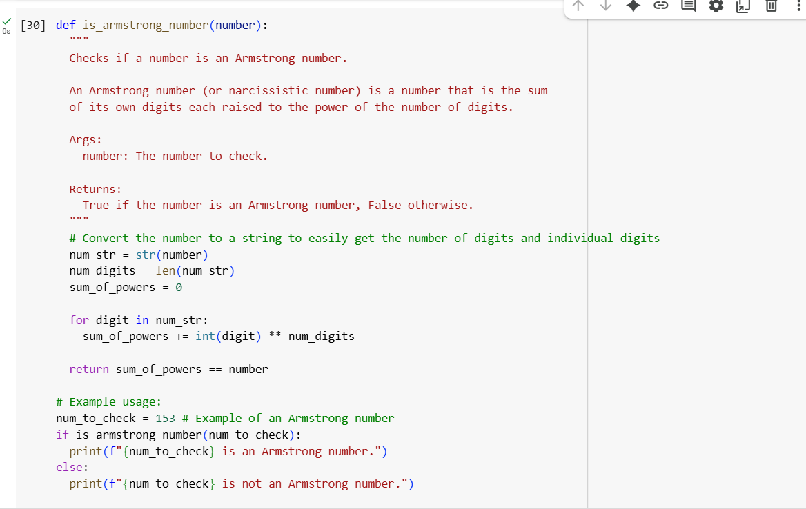

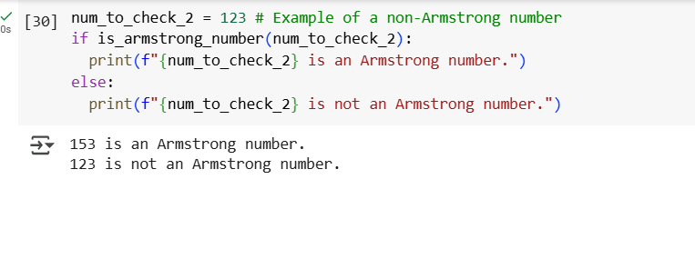

Task Description #3  
● Ask Gemini to explain a Python function (e.g., is_prime(n) or  
is_palindrome(s)) line by line.  
● Choose either a prime-checking or palindrome-checking function  
and document the explanation provided by Gemini

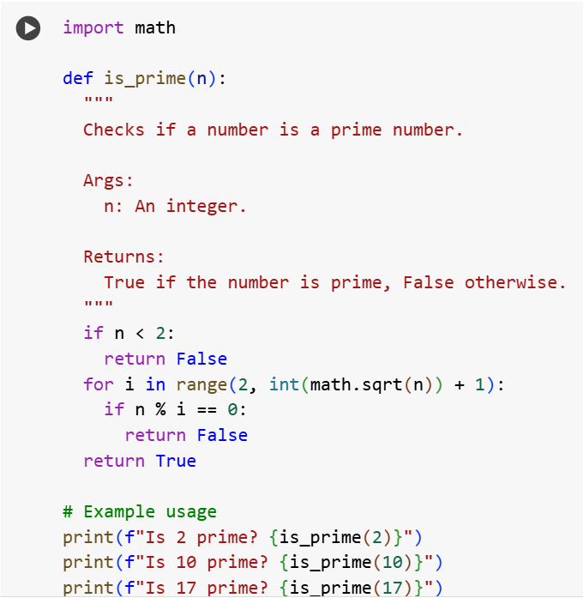

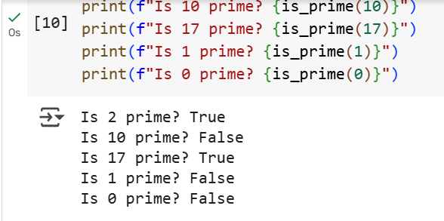

EXPLANATION:

Data Analysis Key Findings

* A Python function is_prime(n) was successfully created to check if a number is prime. The function correctly handles edge cases like numbers less than 2 and utilizes an optimized approach by checking for divisors only up to the square root of n.
* A prompt was constructed to request a line-by-line explanation of the is_prime function from Gemini.
* A simulated line-by-line explanation of the is_prime function, as if provided by Gemini, was documented.

Insights or Next Steps

* The documented explanation can be directly used as documentation for the is_prime function, improving code readability and understanding.

Task Description #4  
● Install and configure Cursor AI. Use it to generate a Python  
function (e.g., sum of the first N natural numbers) and test its  
output.

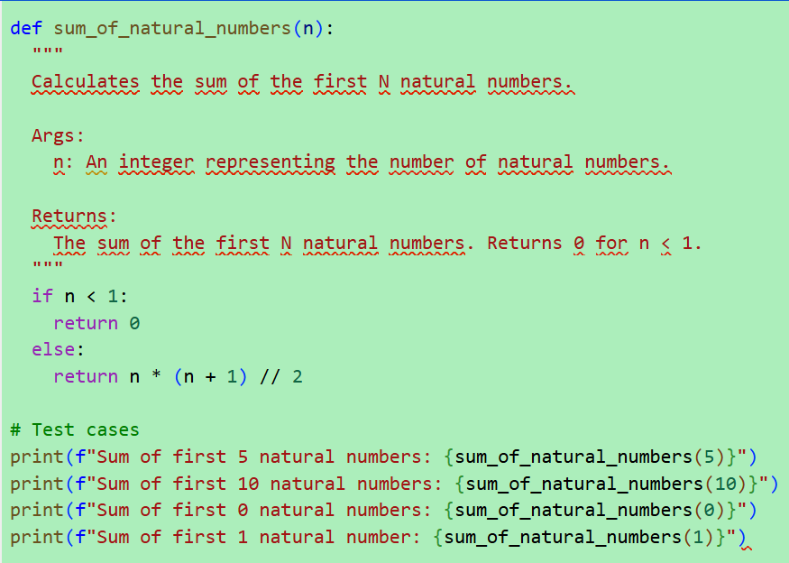

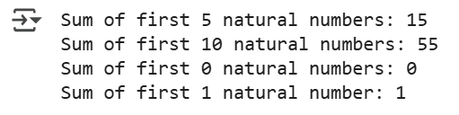

Task Description #5  
● Students need to write a Python program to calculate the sum of  
odd numbers and even numbers in a given tuple.  
● Refactor the code to improve logic and readability

